GL-SL120-3528

[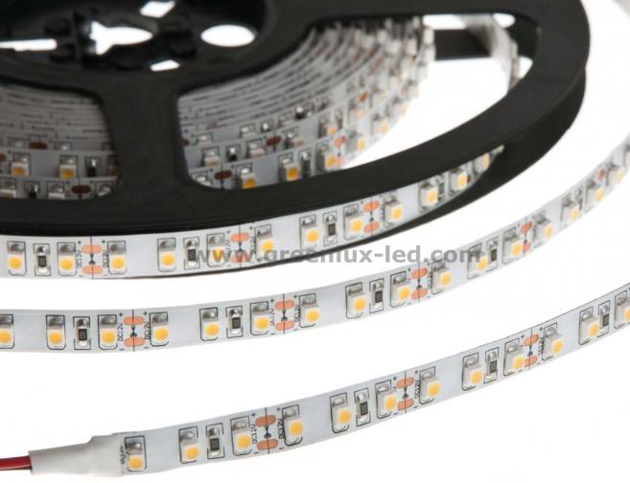](https://www.greenlux-led.com/upload/image/20150926/20150926232812800.jpg)

[](https://www.greenlux-led.com/upload/image/20150926/20150926232812800.jpg)[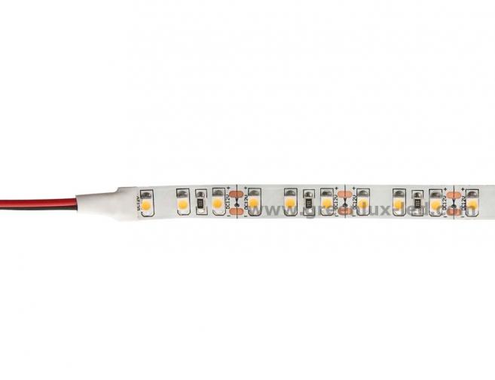](https://www.greenlux-led.com/upload/image/20150926/20150926232812831.jpg)[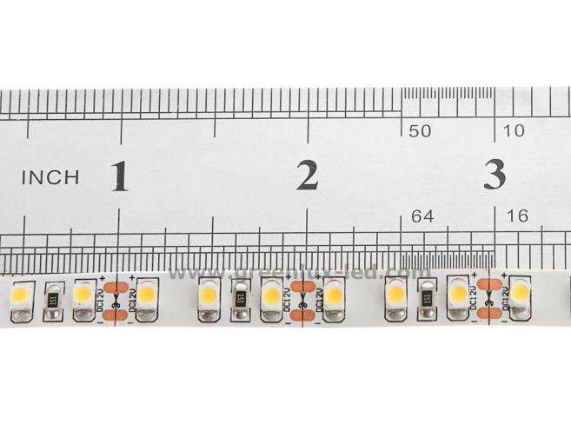](https://www.greenlux-led.com/upload/image/20150926/2015092623281232.jpg)[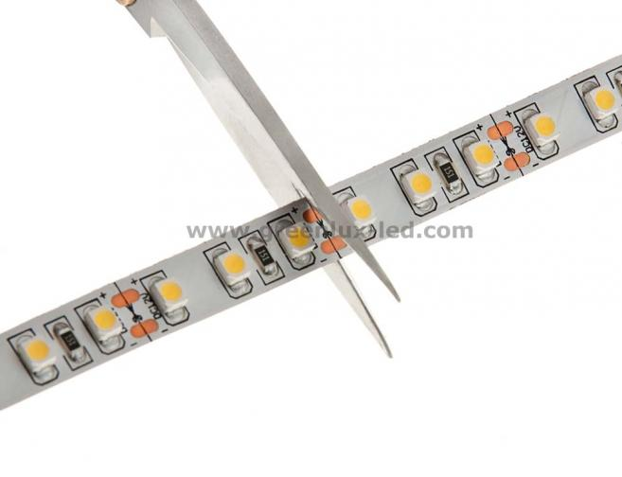](https://www.greenlux-led.com/upload/image/20150926/20150926232813103.jpg)

Description[Feedback](https://www.greenlux-led.com/feedback.html?id=53)

**Features:**

1, Epistar chip SMD

2, 3 years warranty

3, White/Yellow/Black PCB available

4, Every 3 LEDS to cut, 12V and 24V

5, Non-waterproof,waterproof IP65 epoxy surface ,

waterproof IP66 with epoxy surface by tube on bottom,waterproof IP67 injection epoxy with tube outside available

6, lifetime up to 35000 hours

7, CE,RoHS,Erp certification passed

8, Color with white/warm white/natural white,green,blue,yellow,red,pink,purple color available

**Technical Parameters:**

|  |  |  |  |  |  |  |
| --- | --- | --- | --- | --- | --- | --- |
| Item | Color | Lumen | current | Wattage | Size | Beam angle |
| GL-SL120-3528W | White | 6-7lm/led | 0.8A | 9.6W | 8*5000mm | 120 |
| GL-SL120-3528B | Blue | 400-500cd/led | 0.8A | 9.6W | 8*5000mm | 120 |
| GL-SL120-3528Y | Yellow | 400-500cd/led | 0.8A | 9.6W | 8*5000mm | 120 |
| GL-SL120-3528R | Red | 400-500cd/led | 0.8A | 9.6W | 8*5000mm | 120 |
| GL-SL120-3528G | Green | 800-1000cd/led | 0.8A | 9.6W | 8*5000mm | 120 |
| GL-SL120-3528P | Pink | 300-400cd/led | 0.8A | 9.6W | 8*5000mm | 120 |
| GL-SL120-3528P | Purple | 200-300cd/led | 0.8A | 9.6W | 8*5000mm | 120 |

**Applications:**

1, Cove lighting

2, architectural light for canopy,corridor,window,archway,stair,kitchen,hall,living room

3, back light or edge light for signage advertising, light box

4, DIT Lights for home use

5, Path and contour marking

6, decorative light for home, exhibition,residential,buildings,events,holiday and so on

**Dimensions :**

